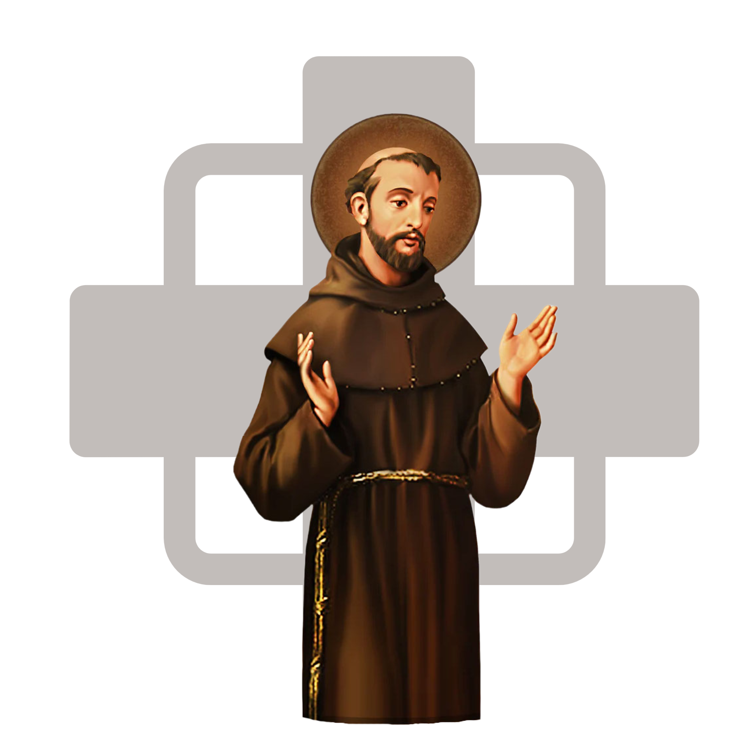
St. Francis of Assisi Catholic Church
844 S Gregg Road, Nixa, MO 65714
RCIA INQUIRY FORM

DATE:________

PLEASE PRINT AND ANSWER BOTH SIDES

FULL LEGAL NAME ______________________________________________________________________

(LAST) (FIRST) (MIDDLE)

SPOUSE’S NAME _________________________________________________________________________

ADDRESS ________________________________________________________________________________

CITY ______________________________________ STATE ______________________ ZIP ____________

PHONE: HOME _____________________ WORK ___________________ CELL ____________________

EMAIL ADDRESS ____________________________________________________________

DATE OF BIRTH _________________ CITY OF BIRTH ________________________STATE________

HAVE YOU EVER BEEN BAPTIZED? YES*____(Can you provide documentation of your baptism) NO____

IF YES, PLEASE STATE DENOMINATION________________________________________________________
(Be specific: Catholic, Methodist, Baptist, Mormon, etc.)

WHAT BRINGS YOU TO INQUIRY?

Please check whatever is appropriate.

________ I think I might want to become Catholic.

________ I definitely want to become Catholic.

________ I’m just looking…am not really sure at this time.

________ I don’t want to join, but just want to know what Catholics believe.

________ I am getting married to / am married to a Catholic, and I would like to know about their faith.

________ I was baptized Catholic but never celebrated First Eucharist and Confirmation.

________ I was baptized Catholic and have received my First Eucharist but never celebrated Confirmation.

MARITAL STATUS

Have you ever been married? Yes No (if “No” you may stop here)
Are you currently married? Yes No

How many times have you been married? _____________

For each marriage, answer the entire set of questions:
Marriage Marriage Marriage
#1 #2 #3
A. Give approximate years you were (are) married. __________ ___________ ___________

B. Did a Catholic priest conduct the marriage ceremony or
meet with you before the marriage to fill out official church
paper work? Yes No Yes No Yes No

C. Was your spouse baptized Catholic at the time of the
marriage? Yes No Yes No Yes No

D. Please list the religion (if not Catholic) of each spouse
Including if he/she was baptized in another Christian faith _________ ________ _________

E. Was your spouse married before he / she married you? Yes No Yes No Yes No

F. If your spouse was married previously, was he/she
married to a Catholic where a Catholic priest conducted
the ceremony and met with him / her before marriage to
fill out official church paperwork? Yes No Yes No Yes No

G. Was your spouse’s previous spouse a baptized Catholic? Yes No Yes No Yes No

H. Is your spouse deceased? Yes No Yes No Yes No

Signature___________________________________ Date________________

Please return form to parish office.

